TIMING

- Give an adaptive advantage for each of the following animal and plant rhythms:
- Kiwi are nocturnal b) Shore crabs are inactive at low tide
c) Sunflowers close at night d) Rabbits are crepuscular
e) Plants open their stomata at night f) Sparrows are diurnal

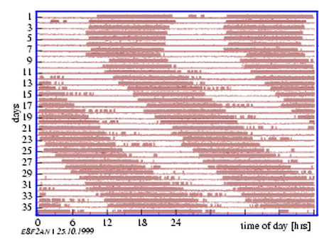
2) The diagram below shows a recording of the activity of a housefly over a 35 day period. For ease of visualisation the data are double plotted (each period of activity on the right being duplicate to the left and shifted up one day.
- What name is given to such a record of activity?
- Under what conditions has the recording been made.
- What is the period of the rhythm under these conditions?
- Explain why, under natural conditions, the period of the rhythmic behaviour is 24 hours.

3) Chrysanthemum is a short-day plant, flowering in autumn. To delay flowering until winter, plants should be treated with a one minute exposure of what type of light and when?

4) Consider the following processes. Label them P for photoperiodic control, C for a response to a period of cold and E for an endogenous rhythm.
- Nocturnal secretion of nectar by moth-pollinated flowers
- Migratory urge in birds
- Breaking of dormancy in buds of deciduous trees
- Sleep movements in French bean leaves
- Laying down of fat in hedgehogs in autumn
- Breaking of diapause in cricket eggs

5) Are plants X, Y and Z long-day, short-day or day neutral, given that the dark bar indicates darkness and the white bar light?
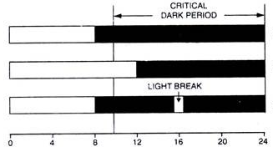
X Y Z
Flowers Flowers None

None Flowers Flowers

None Flowers Flowers

6) A plant normally flowers in 14 hours light/10 hours dark conditions. Explain the effect of red and far red light in the following conditions:
- a short burst of red light at 3am and the plant does NOT flower.
- the red light burst is followed by a far red light burst and the plant WILL flower.
- When the pattern is red, far red, then another red burst, the plant will NOT flower.
ORIENTATION

- Identify the following types of animal orientation responses and give ONE adaptive advantage for each:
- Daphnia swim more strongly towards the light at higher O2 concentrations
- A centipede stops moving when more than half its upper side is touching a surface
- A maggot moves away from a beam of light
- On a vertical surface, a snail crawls upwards after being disturbed
- Slaters move more slowly in damp conditions
- Trout face upstream in a river

2) What is wrong with the statement “Millipedes show negative photokinesis”?

3) Give FOUR advantages of migration and THREE disadvantages.

4) A fish that migrates upstream to spawn is said to be anadromous.
a) How do migrating salmon find the tributary of the stream in which they hatched?
b) What is an advantage to returning to that particular stream?

5) Name THREE kinds of cues that birds use for navigation and for each, state whether it is innate or learned.

6) Explain why birds need to use their biological clock if they are using the Sun as a navigation cue.

7) Define the following terms:
- Taxis b) Kinesis c) Tropism d) Nasty

8) For each coleoptile, explain its growth pattern.
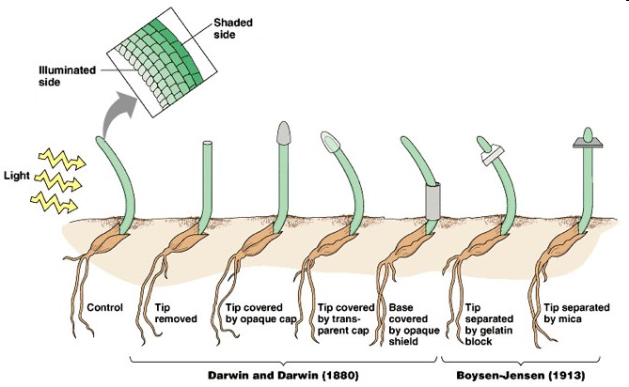
8) Give TWO adaptive advantages of a radicle showing positive gravitropism.

9) Give the common and chemical name for the hormone responsible for photo- and gravitropism and state whether it is inhibitory or stimulatory in plumules and radicles (future stems and roots).
RELATIONSHIPS
1) Give TWO important differences between a predator and a parasite.

2) Explain the following types of parasites and give an example:
- Endoparasite b) Ectoparasite c) Partial plant parasite d) Social parasite

3) For each of the following, state what kind of relationship is involved and why:
- Leaf-cutting ants cultivate fungi on pieces of leaf they collect
- Skuas obtain much of their food by robbing others
- The cattle egret (small white heron) spends time near large mammals like rhino and buffalo, feeding on insects disturbed by their hooves.
- A small crustacean called the tongue-eating louse eats the tongue of a fish then lives in the fish’s mouth where the tongue used to be.
- Deer graze on native shrubs

4) What is intraspecific competition and why would it be more intense than interspecific competition?

5) What is Gause’s Principle?

6) Which resources are most likely to for in:
- Phytoplankton in a shady pond
- Gannets in a breeding colony
- Blackbirds in early spring

7) What is succession?

8) Most mammals are polygamous while in most bird species both males and females contribute to raising the young. What difference in their reproductive biology could explain this difference?

9) Explain why species with precocial offspring have offspring with a higher body proportion of brain and eyes, and a lower proportion of gut, than species with altricial offspring.

10) What is the difference between a territory and a home range?

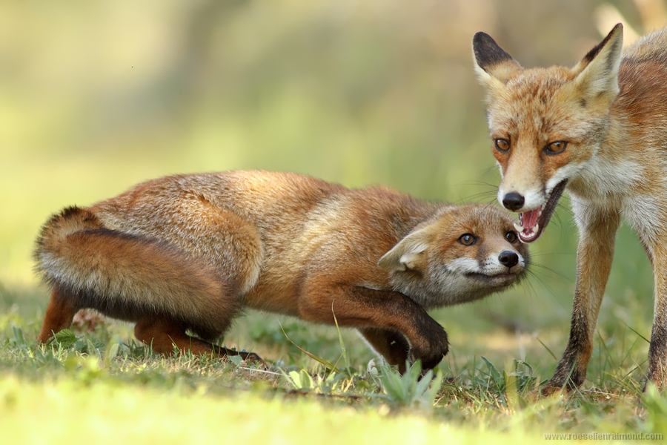
11) a) Identify which fox is dominant and describe the traits of each fox that show this.

b) Explain why this form of communication is helpful for a growing fox family before the pups leave their mother.

ANSWERS
TIMING
- a) Kiwi active at same time as primary food source - insects, weta, worms, snails
b) Crab avoids risk of dehydration and exposure to predators
c) Sunflower protects nectar from nocturnal insects
d) Rabbits allows enough light to forage while remaining dim enough to help camouflage them from predators
e) Plant avoids water loss by transpiration
f) Sparrows need light for successful food gathering, nesting and mate finding

2) a) actogram
b) Initially under natural or 12 light:12 dark conditions, then under constant conditions from day 9
c) From day 10 to day 35, a whole 24 hours has been gained. Therefore the change each day is 24 hours/25 days = 0.96 hours, which added to the natural 24 hours gives a period of 24.96 hours, or 24 hours and 58 minutes (60*0.96 = 57.6 minutes)
d) Because the rhythm is entrained by the zeitgeber of daylight, resetting the flies’ internal clocks each morning. This means they can always be active in daylight where they have a better chance of survival.

3) Chrysanthemum needs to build up enough Pr to flower by being exposed to long periods of darkness. You could stop it from flowering in autumn by exposing it to a minute of white light in the middle of the night because this will turn all the Pr it built up straight back to Pfr.

4 a) E b) P c) C d) E e) P f) C

5 X is short day, Y is day neutral and Z is long day

6 The plant is short-day flowering so needs a long night of darkness to convert enough Pfr back to Pr in order to flower.
- Red light automatically converts all back to Pfr so the plant can’t flower.
- Far-red light makes all this Pfr straight back to Pr so the plant can flower.
- A final red light puts it back to all Pfr so the plant again doesn’t have enough time in darkness for the Pfr to turn to Pr so it can flower.

ORIENTATION
1 a) Daphnia show positive phototaxis because they can find more food higher in the water column during the day and are hidden from predators at the bottom at night
b) Centipedes show thigmokinesis (because the touch response is non-directional but rather to a gradient) because by stopping when in contact with a surface they are likely protected from predators.
c) Maggots show negative phototaxis which helps them prevent desiccation and predation
d) Snails show negative geotaxis (or gravitaxis) because being off the ground protects them from ground-dwelling predators like hedgehogs.
e) Slaters show hydrokinesis (or hygrokinesis) which slows them down in damp conditions so they spend more time there and are less likely to desiccate. Conversely, they move quickly out of dry areas.
f) Trout show positive rheotaxis by orienting into the current. This helps them maintain their position in the stream and means they are facing toward any incoming food items.
2) Kineses are non-directional because they’re a response to a diffuse stimulus

3) Advantages: better food resources, better climate, safe breeding grounds, wider choice of mates
Disadvantages: risk of death in transit (getting lost, storms etc), energy expenditure, increase in disease and pests

4) a) They learned the chemical signature of that stream when were growing up and can identify it again where the stream meets the sea/river.
b) If they survived growing up there, there is a good chance their own offspring will also survive due to favourable conditions.

5) Solar - learned, stellar - learned, magnetic - innate

6) Sun moves across sky from East to West, therefore the bird can’t use it as a fixed point in order to travel in a straight line all day. The bird needs to adjust its orientation to the Sun throughout the day and needs the biological clock to register how much time has passed. For example, to head North at 11am, the Sun must be 30deg to the right, at midday it should be directly overhead and at 1pm it should be 30deg to the left.

7) From left to right:
- Control grows left because auxin moves to the dark side and stimulates cell elongation on that side only.
- Grows straight because no auxin is released by the tip which has been removed.
- Opaque cap prevents phototropic response by blocking stimulus (auxin doesn’t move)
- Light gets through auxin cap so auxins move and elongate right side
- Base doesn’t affect auxin production so no altered response.
- Auxin can pass through gelatin, suggesting it is water soluble
- Auxin can’t pass through mica, suggesting it doe in fact come from the tip and move down the stem.

8) The plant gains a better water supply deeper in the soil and is also more securely anchored by growing downwards.

9) Auxin, indolyl-3-acetic acid, IAA, in high concentrations stimulates cell elongation in plumules, inhibits it in radicles.

RELATIONSHIPS
- Parasites are smaller than their host, need the host to stay alive so try not to kill them and are usually dependent on one type of host only. Predators kill their prey, are usually larger and often have several different prey species.
- a) Endoparasites live inside the host, e.g. tape worms, ringworm, flukes
b) Ectoparasites live on the outside of the host e.g. fleas, ticks, lice
c) Partial plant parasites are plants that take water and minerals from other plants but not energy because they do photosynthesis for themselves, e.g. mistletoe, convolvulus, striga (witchweed)
d) Social parasites take advantage of interactions in social group, e.g. cuckoo, spotted catfish

3) a) Mutualism - fungi get food, ants gets their food from the fungi
b) Social parasitism - skua get food and their victims lose their food but aren’t physically injured
c) Commensalism - the egret gets food, the rhinos and buffalo aren’t affected
d) Parasitism - the louse gets food from the tongue and then whenever the fish eats, the fish is harmed but not killed and continues to be harmed by the louse eating part of its food.
e) Herbivory - the deer get food and the plant lived but has been harmed by lost leaves.

4) Intraspecific competition is competition between members of the same species for resources such as space, mates, food, light, minerals etc. It is more intense than competition between species because all of the individuals have the same needs and ecological niche, whereas other species might have some overlap but also some different requirements.

5) No two species can permanently occupy the same niche in the same habitat.

6) a) light they need for photosynthesis
b) nest sites
c) breeding territories

7) Succession is the progressive, predictable change in species composition in a community over time, e.g. after a forest fire, weeds recolonise first, followed by shrubs then young trees and ferns, then mature trees with different strata beneath them.

8) In birds, one parent always needs to be on the nest but it doesn’t necessarily have to be the female. They need to work together to keep the eggs warm or one parent would starve or abandon the nest. In mammals the young are dependent on the mother alone for food and she is able to eat while supporting them.

9) Precocial offspring need to be able to find food for themselves, hence their brain and eyes need to be further developed. Altricial offspring are born in an earlier stage of development and need to grow extremely quickly so have a well-developed gut.

10) A territory is a defended area where young are raised and animals sleep. The home range is the large area that they will normally visit and may overlap with neighbours. In human terms your house is your territory but your home range includes school, the supermarket, the sports field, movies etc

11) a) The right fox is dominant, it is standing upright, has teeth bared and ears are pointed forward. The left fox is submissive and has made itself seem smaller by crouching, flattening ears, hiding teeth, curling in tail.
b) The foxes have an acknowledged hierarchy which helps them to manage competition without the need for physical fights which could injure both parties.

